Software Requirements Specification

For the software requirements, please consult the following diagrams and their corresponding software specifications. Since the progress is still in progress and is currently identified on the alpha stage, the stated requirements on this document is far from absolute.

# Cycle 1: Console Based QA

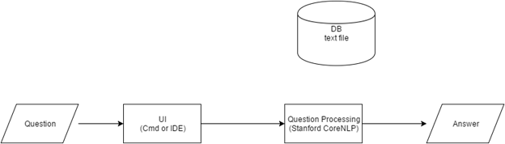

# Cycle 2: Browser Based QA

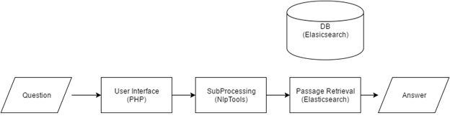

# Cycle 3: Apache UIMA Based QA

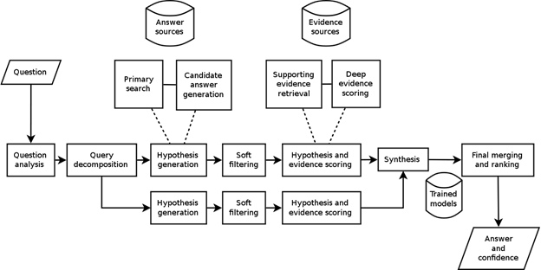

No software specification exists for the third release of our system as it is still on its conception stage.